Department of information science and engineering

**WORDLE**

**PYTHON PROJECT ON**

**SYBMITTED BY:**

**AKSHAY PRASHANT HEGDE**

**ABSTRACT**

Wordle is the game using the Python Programming language is the simple game. It is the most popular word guessing game on the internet today. We are doing this as the Mini Project to boost our programming skills and understand the logic in the Python Programming language. In this Project we the random module to pick the random word from the list of word which is saved in text file. Another module we used is this project is termcolor. We used this module to print the letter in color which is in correct position or letter in the guessed word. We implemented the game in such a way that user or player can play the game continuously. In this game the user or player must guess the random five letter word. If the user or player guess the word within the six attempts, he won the game, and the score is increased by one. There will be six attempt to guess the word. If the user failed to guess the word six attempt the player loses the game, and score will become zero.

**TABLE OF CONTENT**

Content Pages

**CHAPTER 1: INTRODUCTION-----------------------------------**

**CHAPTER 2: LITERATURE REVIEW--------------------------**

**CHAPTER 3: OUTCOME OF LITERATURE &**

**OBJECTIVES-------------------------------------**

**CHAPTER 4: PROBLEM STATEMENT------------------------**

**CHAPTER 5: METHODOLOGY----------------------------------**

**CHAPTER 6: ALGORITHM AND CODE SNIPPETS--------**

**CHAPTER 7: TESTING----------------------------------------------**

**CHAPTER 8: RESULTS AND SNAPSHOTS-----------------------**

**CHAPTER 9: CONCLUSION------------------------------------------**

**CHAPTER 1: INTRODUCTION**

The aim of this project is to use python program to form an wordle game with easy texted. Python is the powerful multipurpose language utilized by multiple giant companies. It has simple and easy-to use syntax making it the right language for somebody trying to be told computer programing for the primary time. It is a high-level a language, and its core design philosophy is all about code reusability and a syntax that permits programmers to precise concepts in an exceedingly few line of code.

WHAT IS WORDLE?

The wordle game is a word guessing game which is web-based created and developed by Welsh and s/w Eng. Josh Wordle. Later this was owned and published by New York Times Company from February 2022. Wordle initially created for himself and his partner to play, eventually he making it public in October 2021. And it gained large popularity in December 2021, and later the it was created in various languages apart from English. The mechanics are nearly clone of the 1955 pen-and paper game Jotto and also the television broadcast franchise Lingo. A player has 6 attempts to guess a 5 letter word, for every guess within the type of colored tiles indicating when the letters match or occupy the right position. A green color means predicted the right placement of the word. A yellow color indicates the letter is present within the word, but your prediction had the incorrect position. And lastly a gray tile means the letter isn't present within the word. Every day the it encompasses a single daily solution, with all players attempting to guess the identical word, and also the player can play the sport one time during a day.

**CHAPTER 2: LITERATURE REVIEW**

1. Guess the word:

In this game the user and the wordBot (AI agent) try to match up in a game of

word association (which is powered by machine learning).

It can be played as both the giver and the guesser. The giver will have a secret

word which the guesser has to try and guess it. The giver provides the guesser

with single word clues. The player will have up to 5 turner to guess the secret

word

1. Hangman:

It is a popular well-known game in which the player tries to guess the missing word one letter at a time before the hangman is completely drawn.

1. Wordle on commodore 64:

Commodore 64 was released nearly 40 years ago. It is an 8-bit computer packed with 64KB of memory. Spiro Harvey has been working on the popular game wordle designed on the commodore 64. The game more or less works similar to the original Wordle game you have six tries to guess the word correctly.

1. Sedecordle:

Sedecordle is a wordle type game but the player has to guess 16 words in a single round of the game. You have 21 attempts to try and guess the 16 words.

1. Duotrigordal:

Duotrigordal wordle is a game in which the player can play multiple times in a day, in either practice mode or challenge mode. It is a game in which the player has to guess 32 words in 37 attempts with 32 boards. There are original words and increased difficulty compared to sedecordle wordle.

1. Scrabble AI game:

It’s a board game AI in which the algorithm successfully generates a high scoring Scrabble game by analysing the board and coming up with a high score word to win.

1. Dordle:

In this game you have to guess 2 five letter words at the same time but you can only input one word guess at a time.

1. Quordle:

This version is equivalent to playing four wordles at a time. The player has a total of 9 guesses to guess all of the 4 five letters’ words in the game.

1. Octordle:

This game lets you solve eight-word games at a go and the player has a total of 13 guesses to solve all of the 8 words.

1. Kilordle:

Its another wordle spinoff in which you play several wordle game simultaneously and each guess is applied to each game individually. In this there is no limit on the number of guesses each player have.

**CHAPTER 3: OUTCOMES OF LITERATURE AND OBJECTIVES**

1.Guess the word:

Figure 1 shows the game when the player plays as the guesser and the AI generates a random word for the player to guess it.

Figure 2 shows the game when the player plays as a giver the console will generate a random word and ask the player to give one-word clues for the AI to try and guess the secret word. Lastly figure 3 shows the game results.

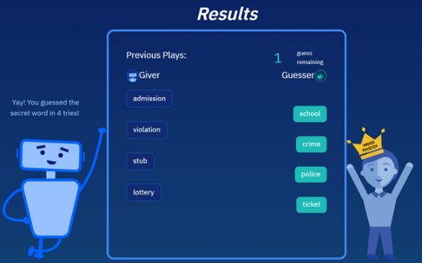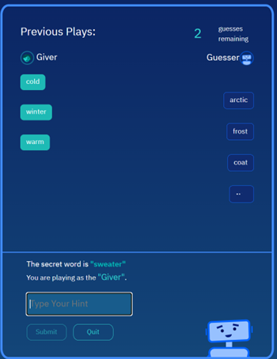

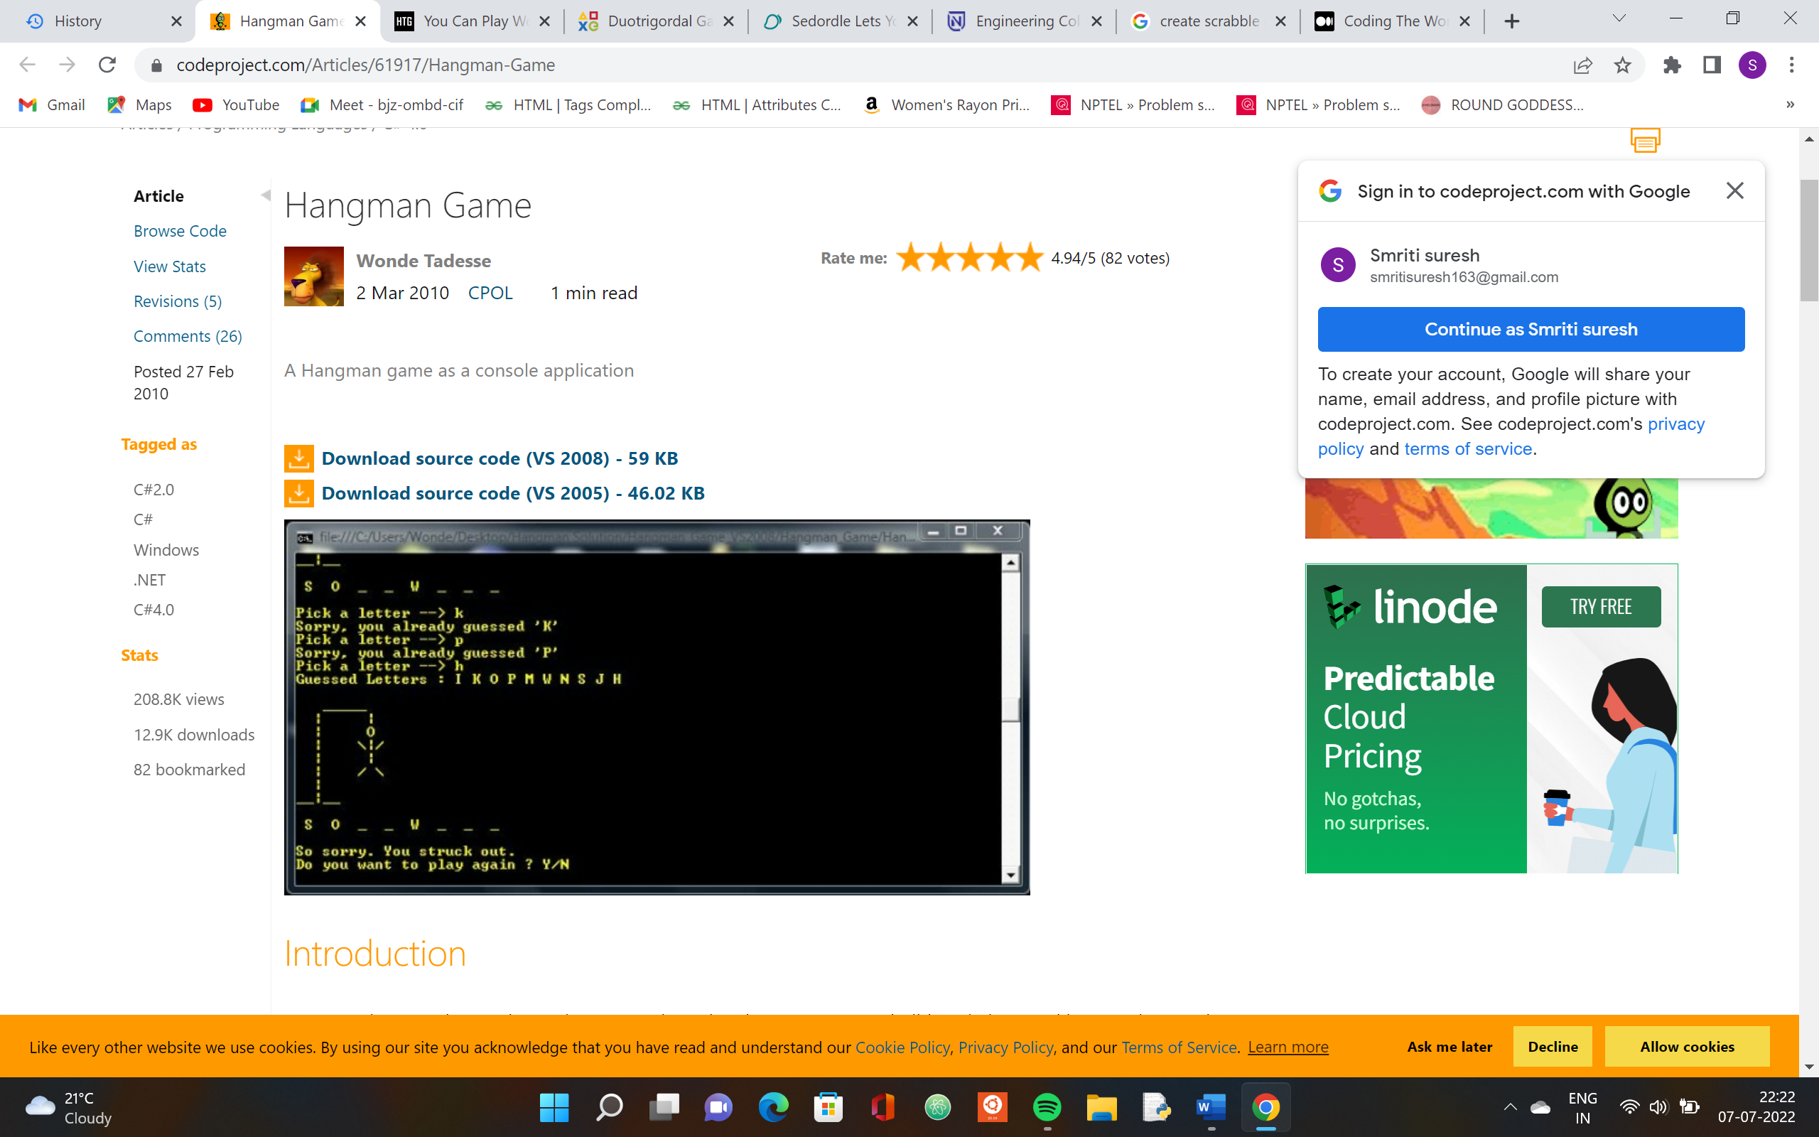 2.Hangman:

3.Wordle on commodore 64:

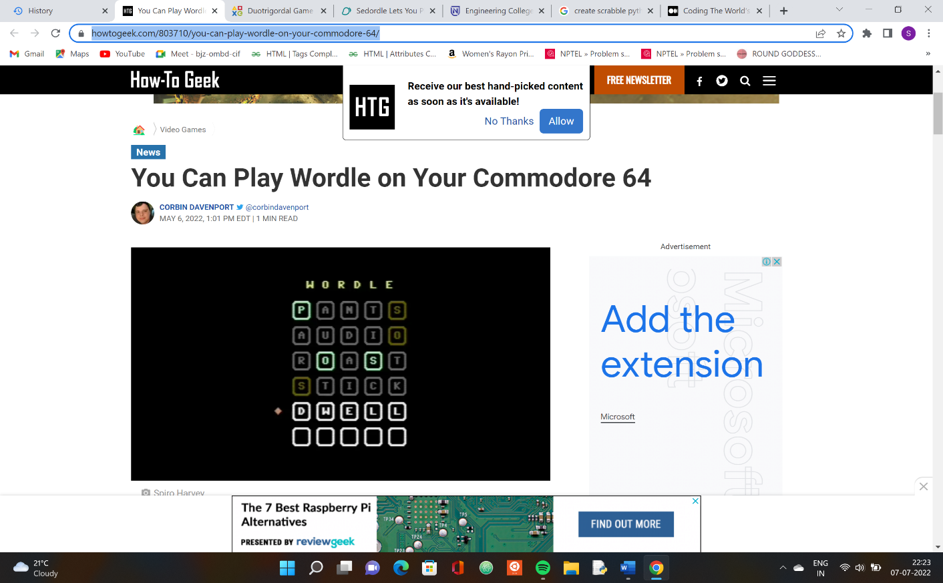 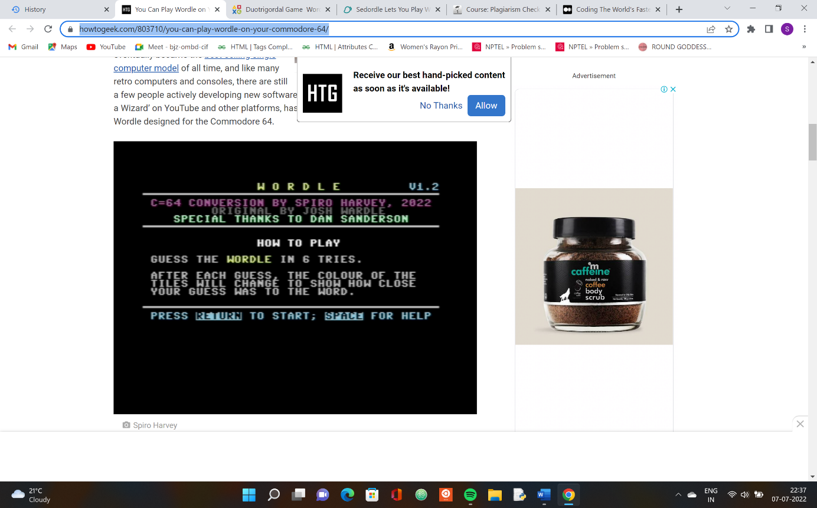

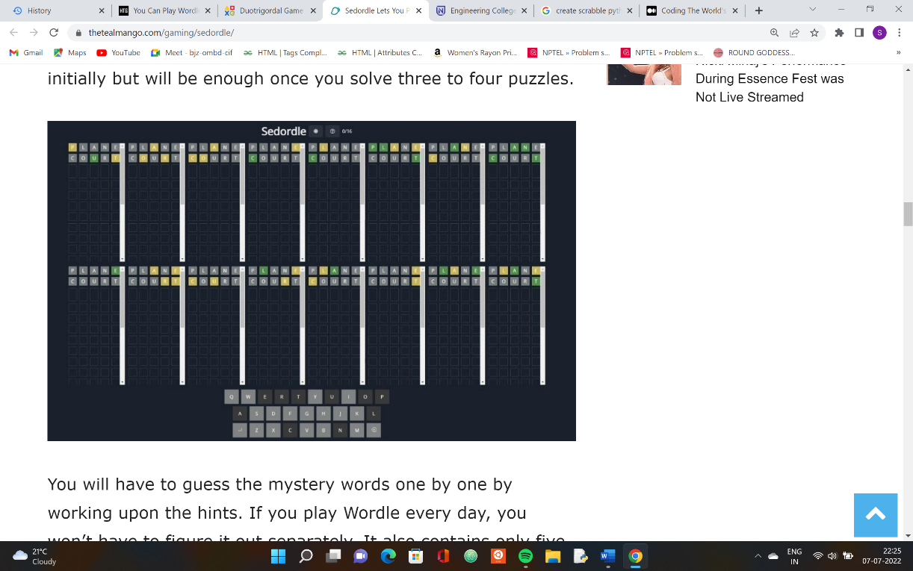4.Sedecordle:

Figure 6: The Sedecordle game

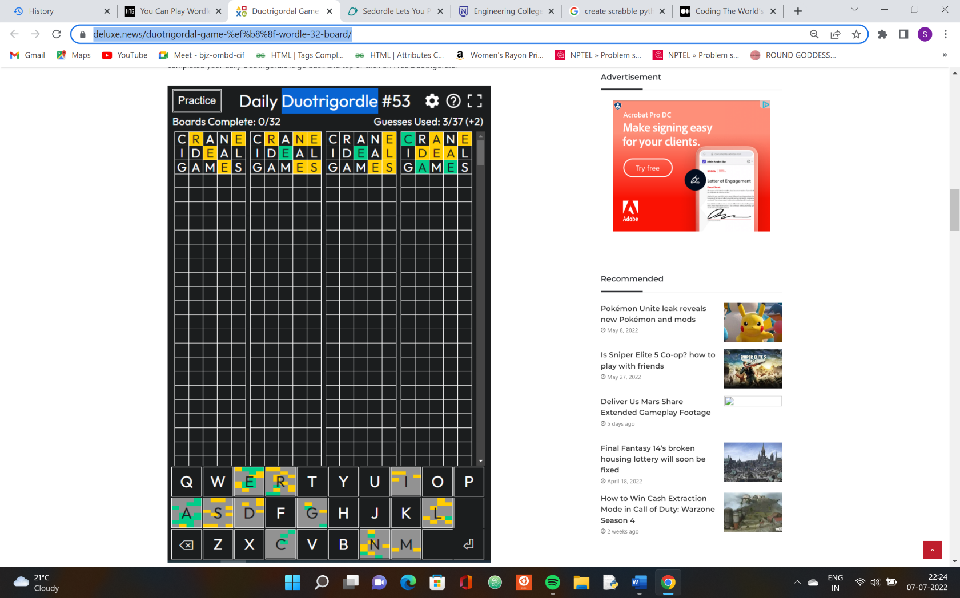5.Duotrigordal:

Figure 6: Duotrigordal Wordle

6.Scrabble AI game:

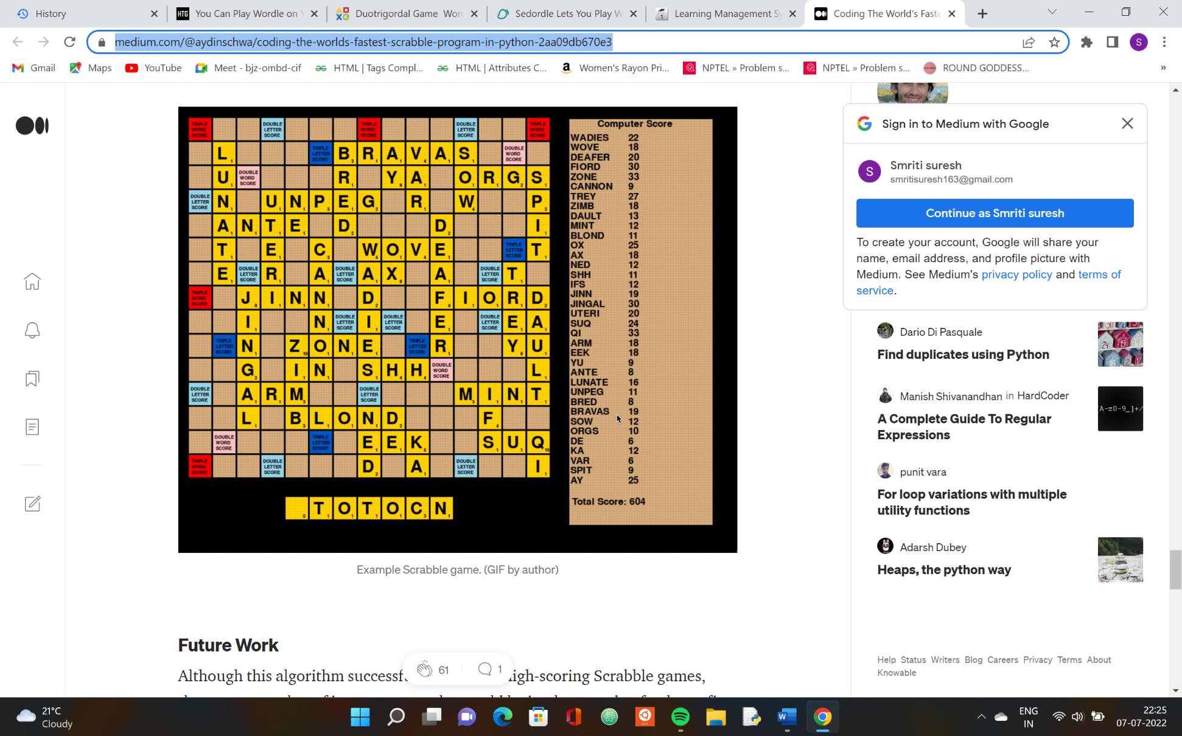

Figure 7: AI trying to guess words with the highest scores

7. Dordle:

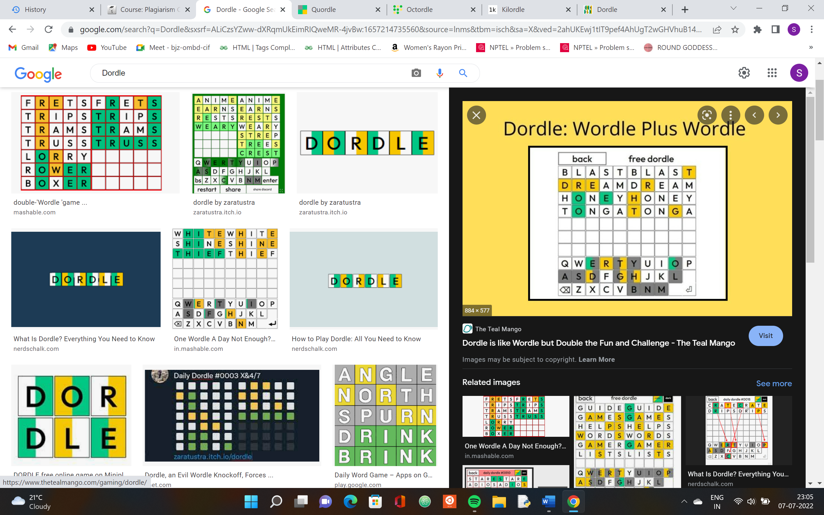

Figure 8: dordle

8. Quordle:

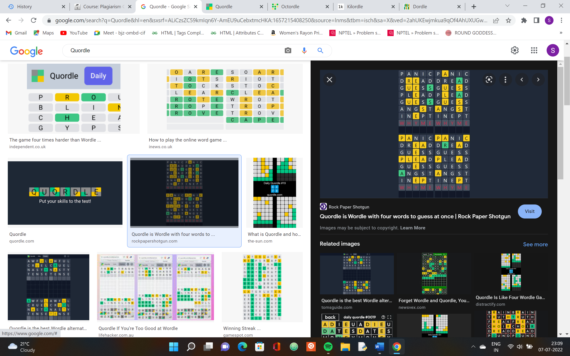

Figure 9: Quordle

9. Octordle:

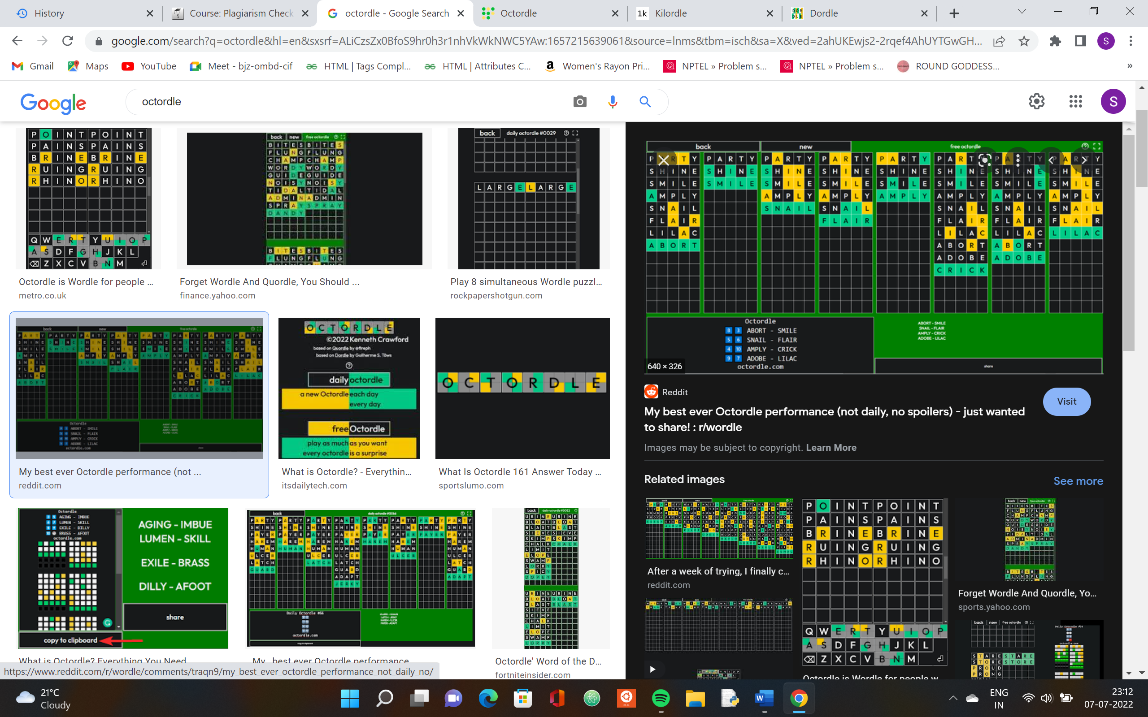

Figure 9: Quordle

10. Kilordle:

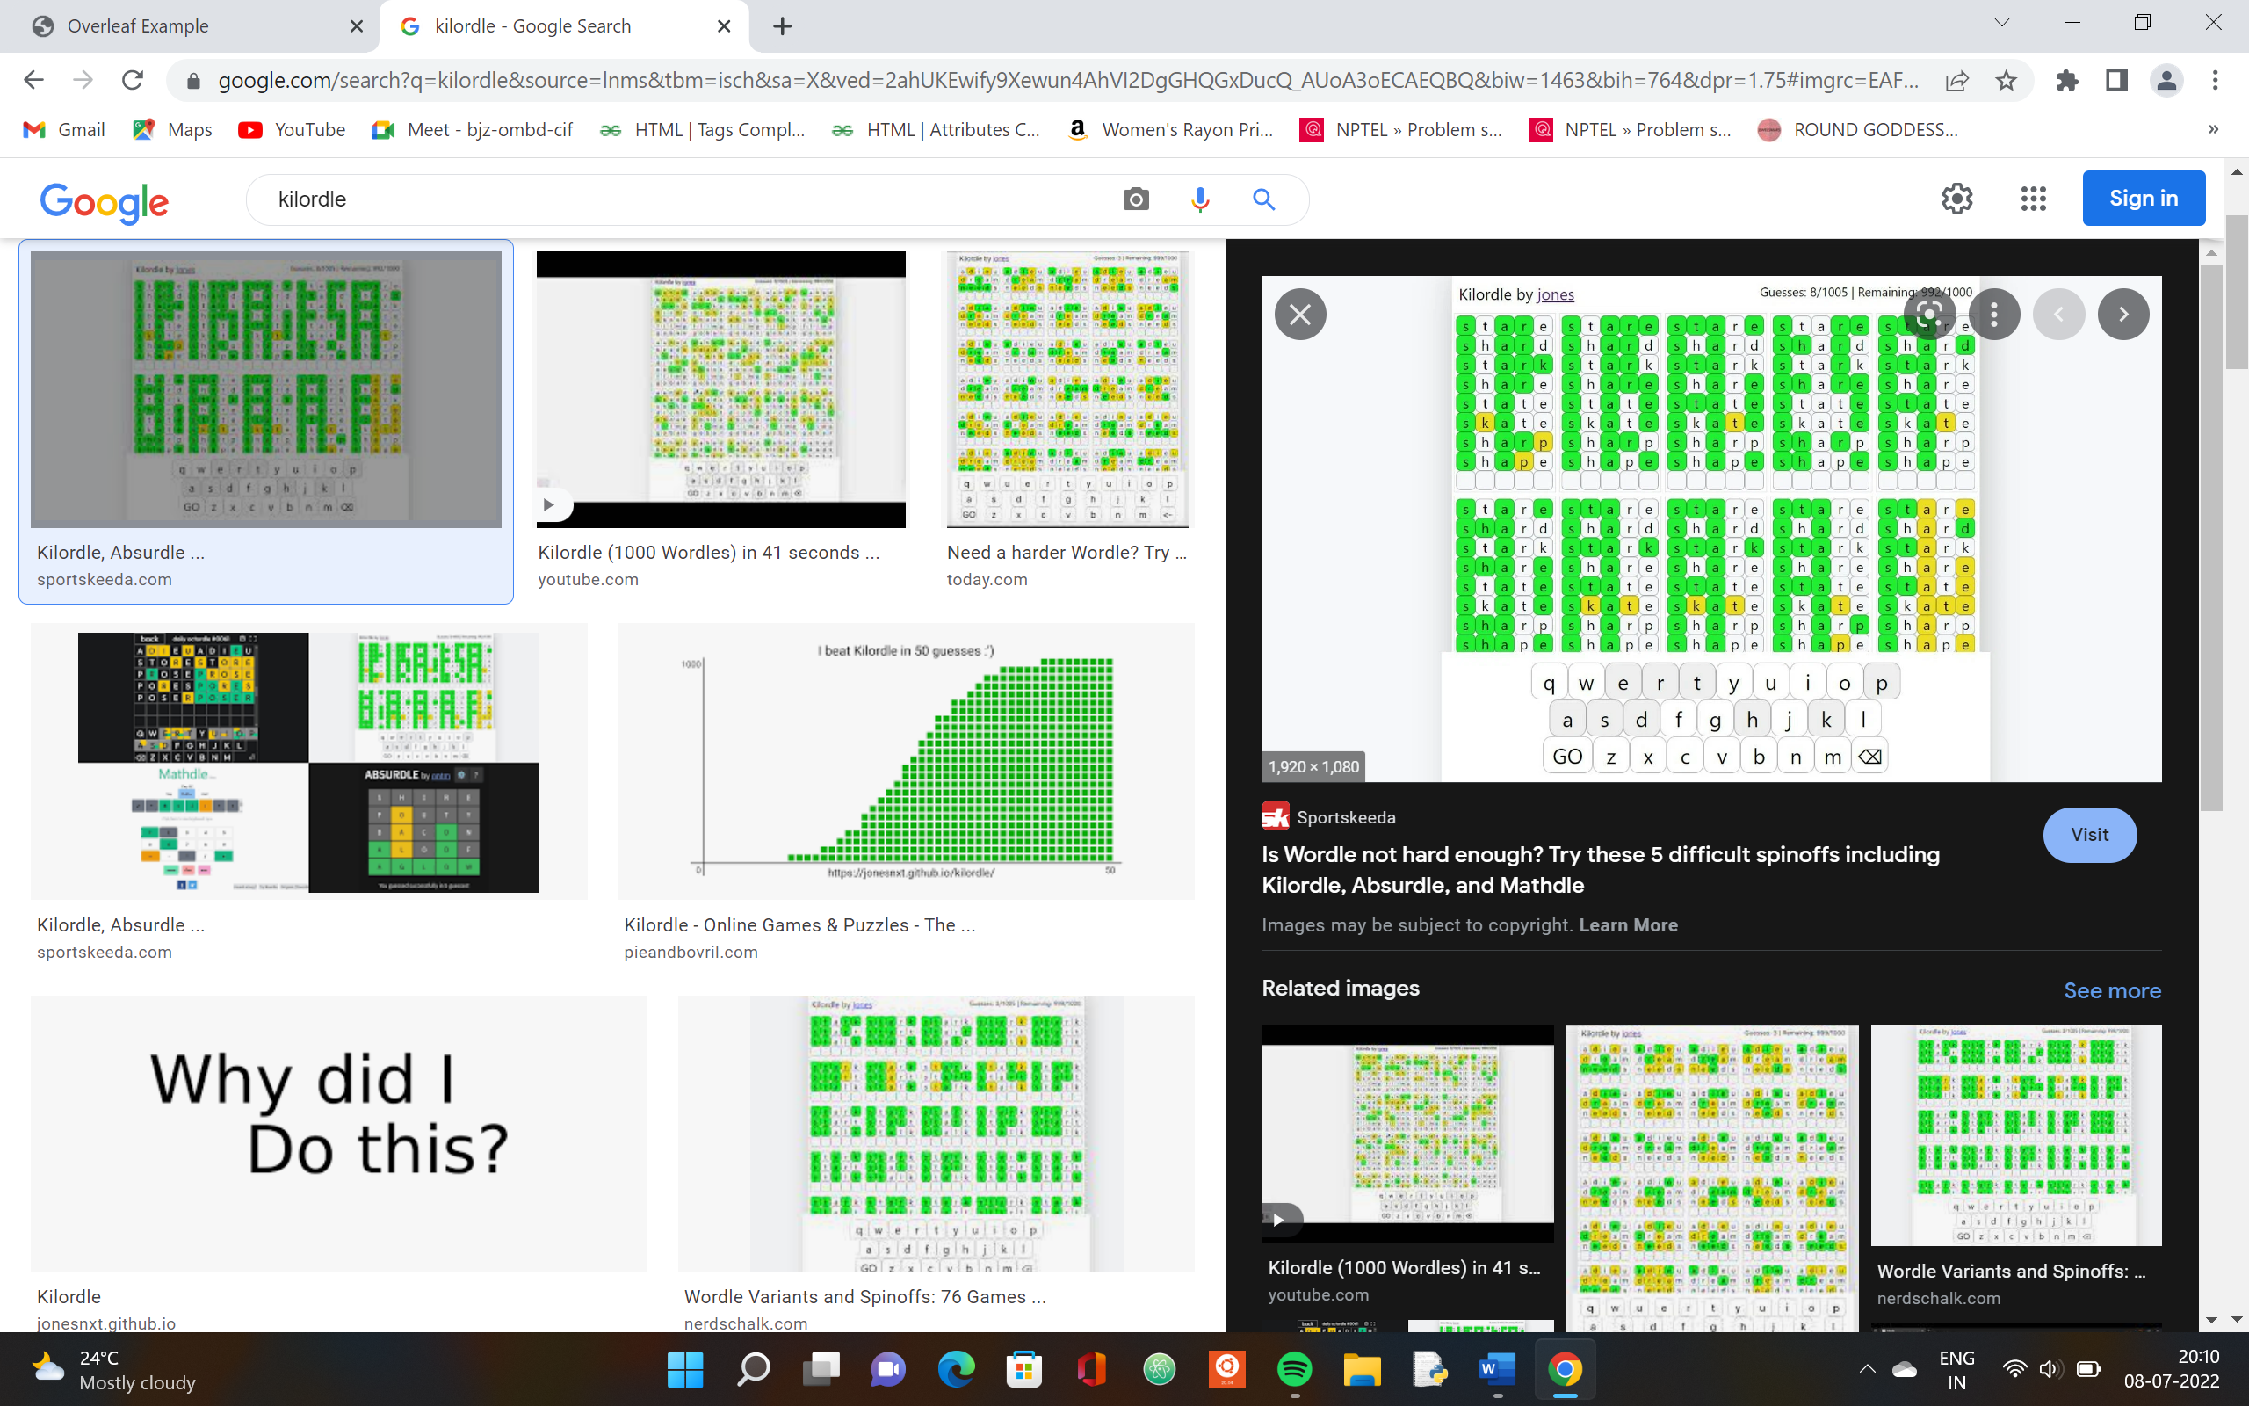

Figure 10: kilordle

**OBJECTIVE**

Build a python program that plays wordle.it should make guesses of 5 letter word and try and figure out the ultimate answer in 6 guesses at most.

If the guess letter turns green that means you have predicted the correct placement of the word.

If the guess letter turns yellow that means the letter is present in the word but your prediction had the wrong position.

And lastly a grey tile means the letter is not present in the word.

If the word is guessed within 6 attempts, the player has won the game and the game will display the correct word at the end, and players scores will be displayed on the console

**CHAPTER 4: PROBLEM STATEMENT**

The game requires a list of words out of which the interpreter should choose a word at random. The user first has to input their first guess. If the random word contains that guessed letters in the correct position it will be shown in green color as the output.

The user will be given a total of 6 tries to try and guess the random 5 letter word within the given set of tries

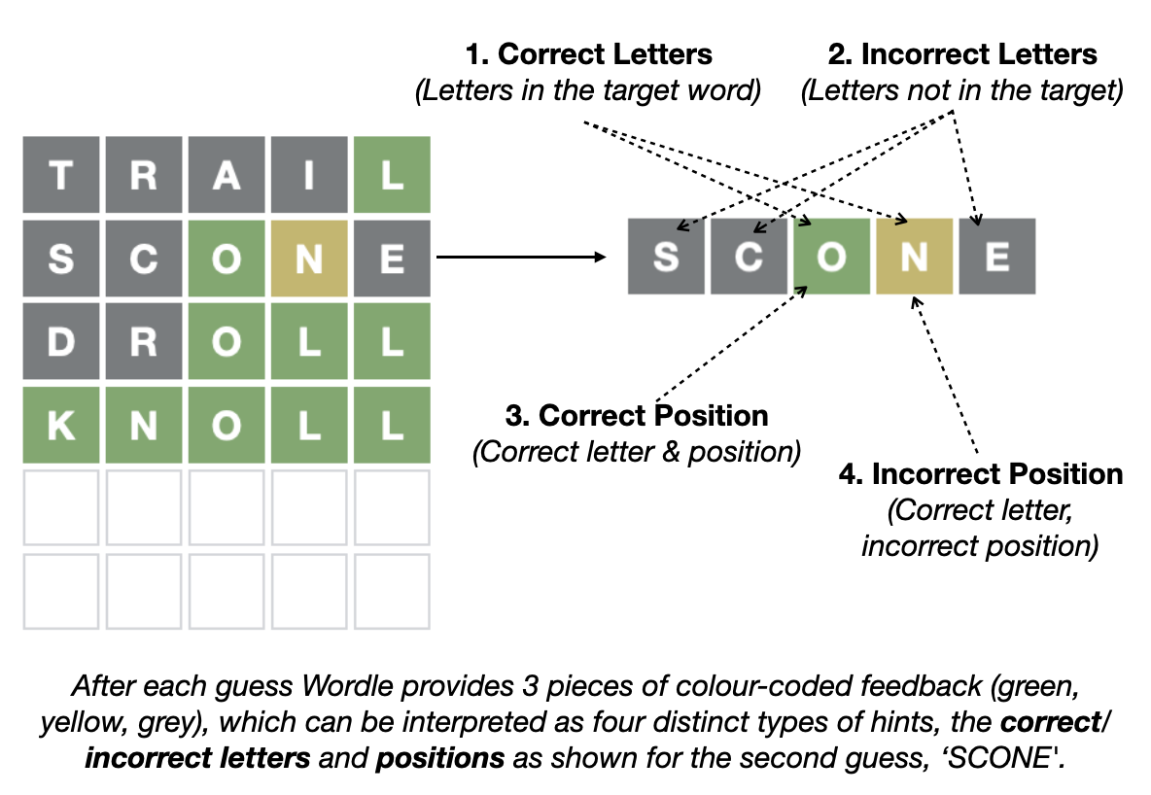**CHAPTER 5: METHODOLOGY**

The above image is the reference for how the game works. Basically, when the player enters the input or guess the five letter word, it will compare with each of the letter in the original letter. For example, in the above reference the player guessed the word “SCONE”, and it compare with the original word “KNOLL”.

In the word “SCONE” , S and C and E are not in the target. O is correct letter and in right position, hence it is showing in the green color. N is in the original word, but not in the right position, hence it is showing in the yellow color.

This is the method of playing the wordle game.

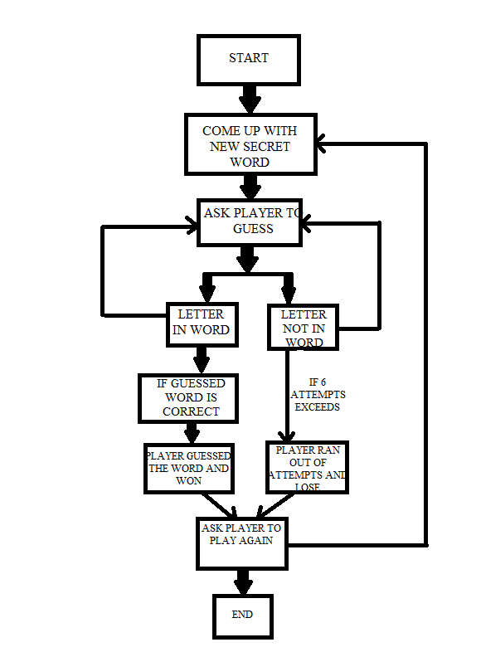

The above figure is the working diagram of our project wordle.

In this method the game is working.

**CHAPTER 6: ALGORITHM AND CODE SNIPPET**

Algorithm for this code is

Wordle game

\\Input: Enter the five-letter word to guess

\\Output: If the guessed word is correct, won the game.

Display Enter the five-letter word to guess

play_again<- null

While play_again is not equal to “exit” do

Word<- function read_random_word(“word.txt”)

for attempt in range 1 to 6 do

guessword<- input the guess in lower case letter

if guessword is in the word at exact position do

display the letters in green color

else if guessword is in word but not in right position do

display the letters in yellow color

else display the the letters in white color

if the guessword is equal to the word do

display You guessed the word in (attempts) guesses

break

else if attempt exceeds six do

display You didn’t guess the word in six attempt

play_again<- input ‘exit’ to exit the game else hit enter to continue

read_random_word(“word.txt”) function

\\input: take the input text file from the main function

\\output: return the random word from the list of word from text file

file<- open the text file word.txt

words<- read the lines from text file

close the file

return the random choice five letter word from text file

Important Code Snippet

1) In this Project we are using *read_random_word* function to return the random word from the text file *“word.text”* which consist of list of five letter words.

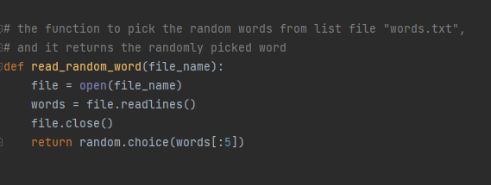Here is the Code snippet

In the above function we are accepting the *file_name*  one text file from the main function. Next, we are opening that file using *open()* functionand store it in the variable name *file*. After that we are reading the lines from the file using the built-in function *readlines() .* And after that we are closing the file using *close()* function *.* Finally we are returning the random word from the list of word and we are only returning five letters only from word. We are using *random* which we are importing from the package or module *random.*

2) For coloring the letters

In this program we are using *termcolor* package for coloring the letters in word.

If the letter is in correct position as the original word, that letter in word which the player guessed is shown in green color. If the letter exists but not in correct position, then it is shown in yellow color. Otherwise, it will be shown in white color.

Here is the code snippet.

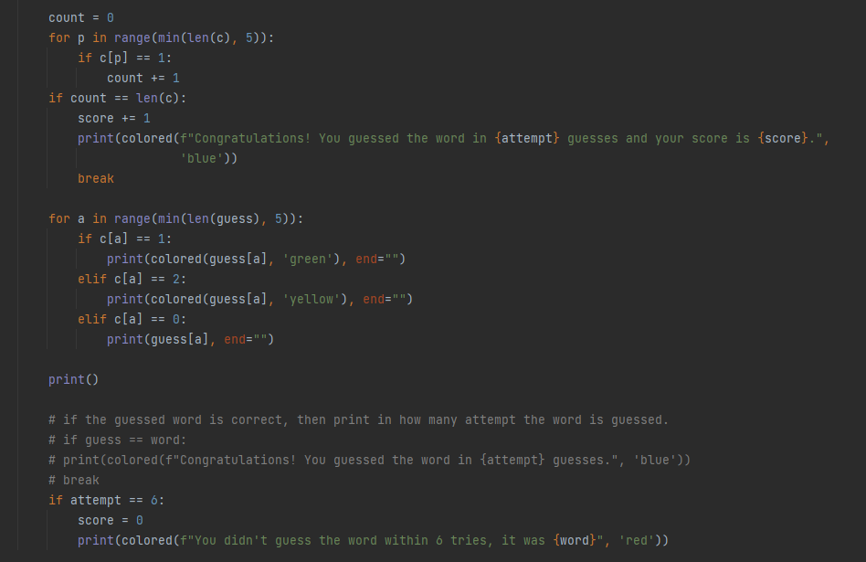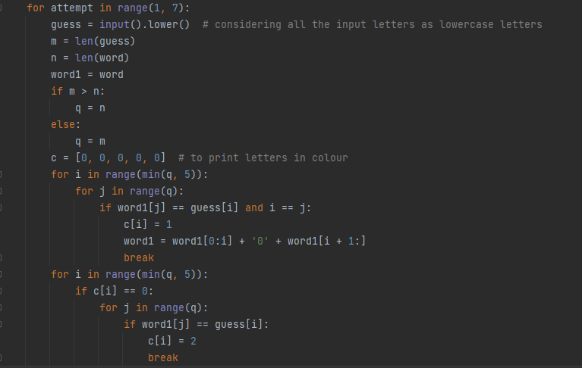

In this code we are using one list which consists of five values which is initialized to zero. While traversing or comparing the words if the letter is in correct position then that index value of list is initialized to 1 , and if the letter exists but in wrong position then that index is initialized to 2.

Finally while printing, those values are 1 in list are printed in green color , those values are 2 , that are printed in yellow color, if it is 0 then it is printed in white color.

If the guessed word is equals to the original word , then player guessed the correct word and score is incremented by one.

If the player fails to guess the word in 6 attempts then he lose the game and it shows the correct answer and score is again initialized to 0.

**CHAPTER 7: TESTING**

**CHAPTER 8: RESULTS AND SNAPSHOTS**

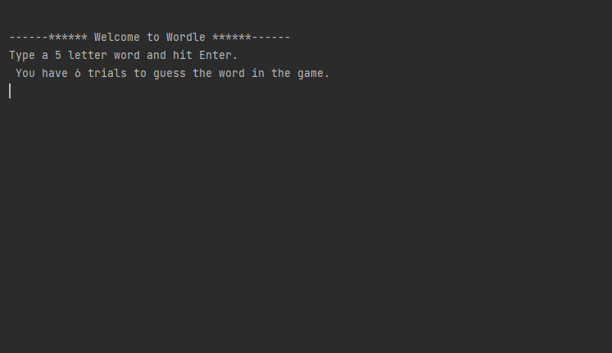

Case 1: Interface of the game

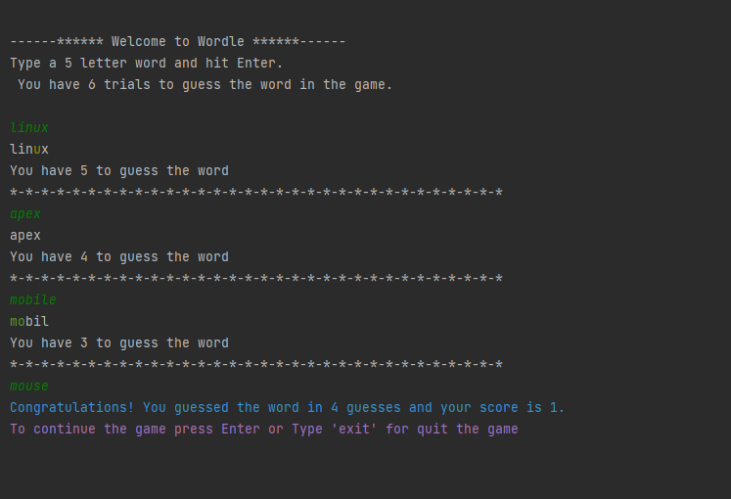

Case 2: For the guessed answer is correct

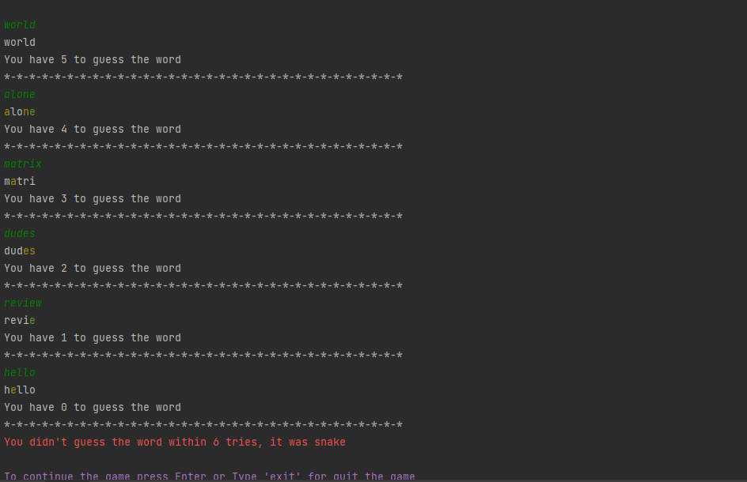

Case 3: Failed to guess the word in 6 attempts

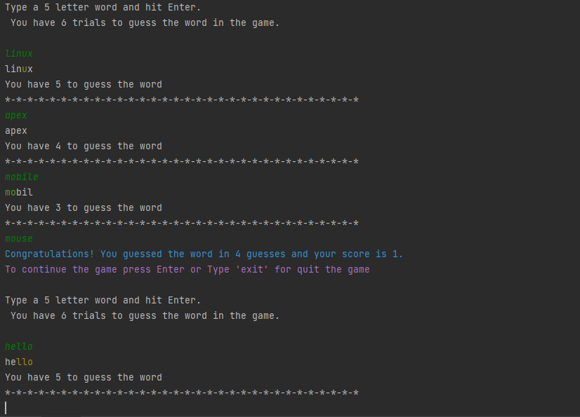

Case 4: Guess the correct answer and giving another attempt to play